Develop A Web Application Using Node-RED

|  |  |
| --- | --- |
| Date | 26 October 2022 |
| Team ID | PNT2022TMID27152 |
| Project Name | Project - IoT Based Safety Gadget For Child  Safety Monitoring & Notification |
| Maximum Marks | 2 Marks |

Steps Followed:

* 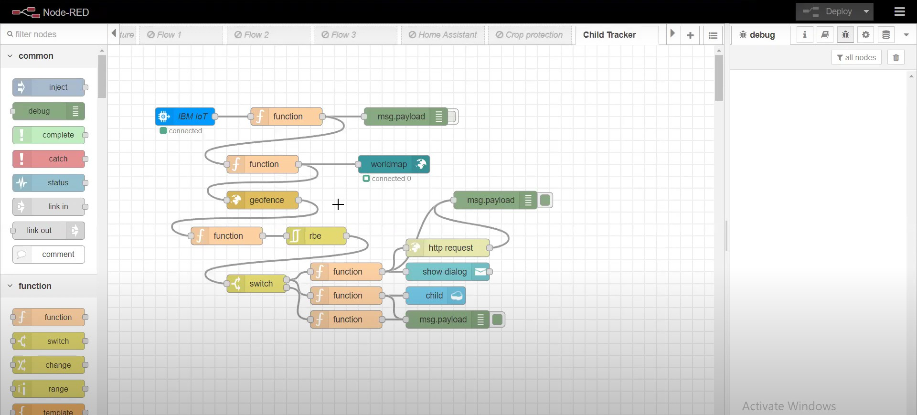Opened a Node-RED project
* Added code to get child location in python

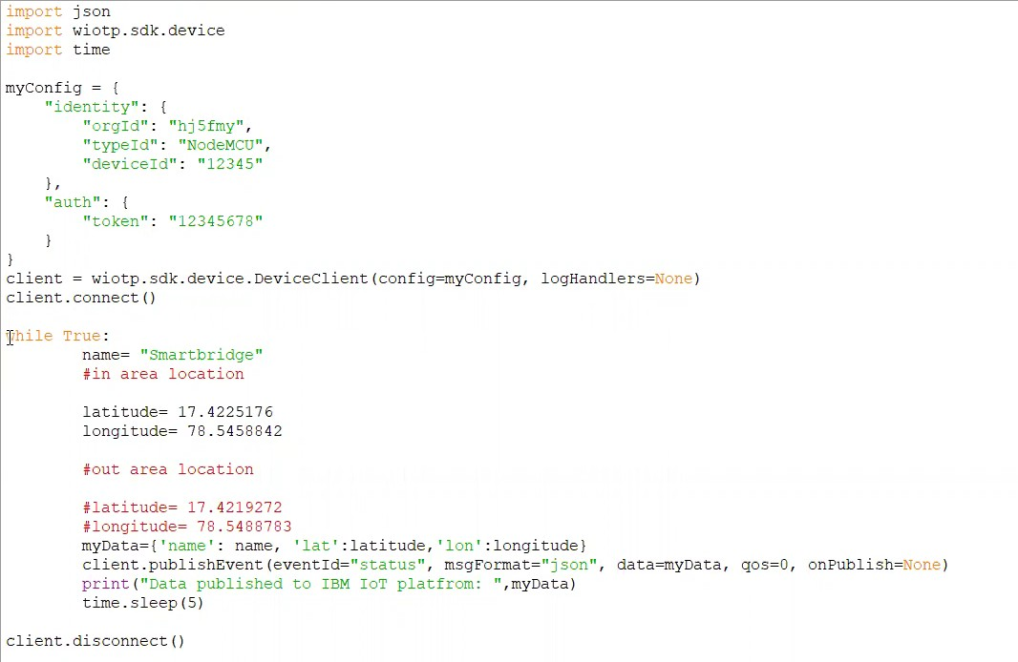

* 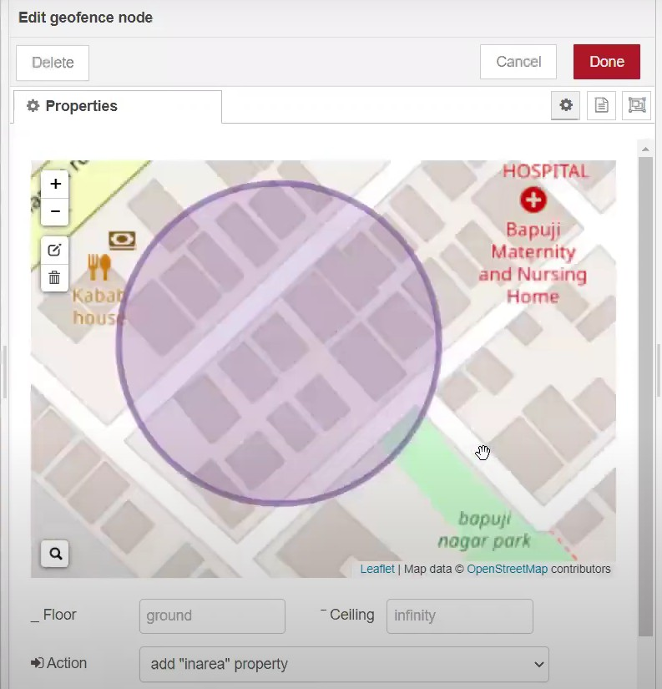Created the GeoFence
* 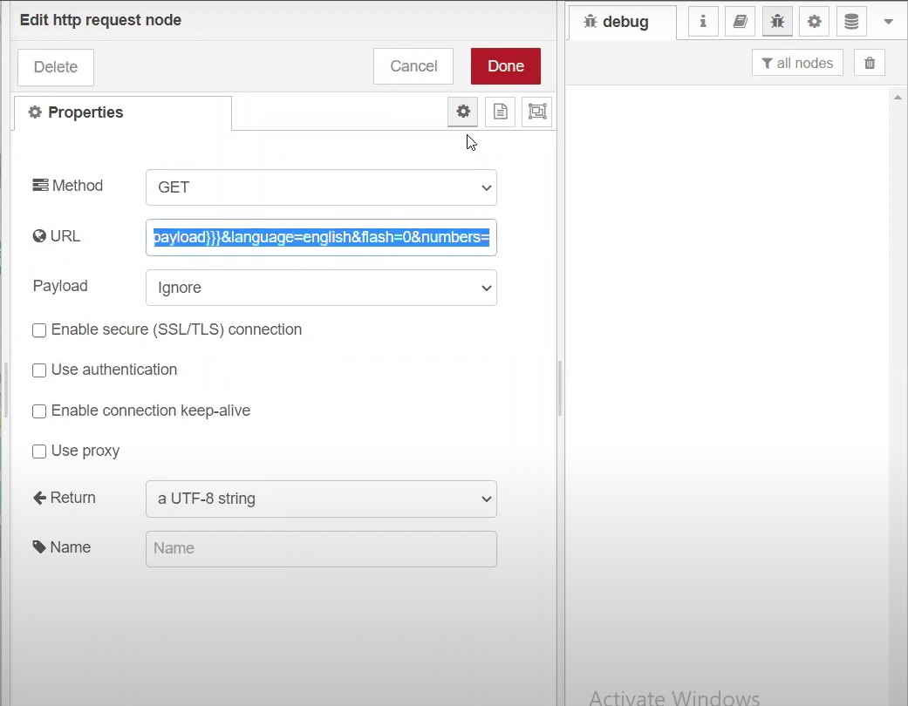Editing the HTTP Request URL
* Located the child

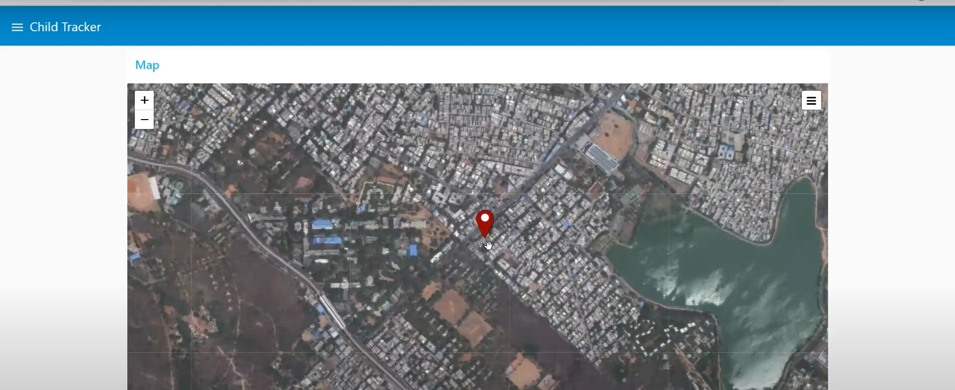

* 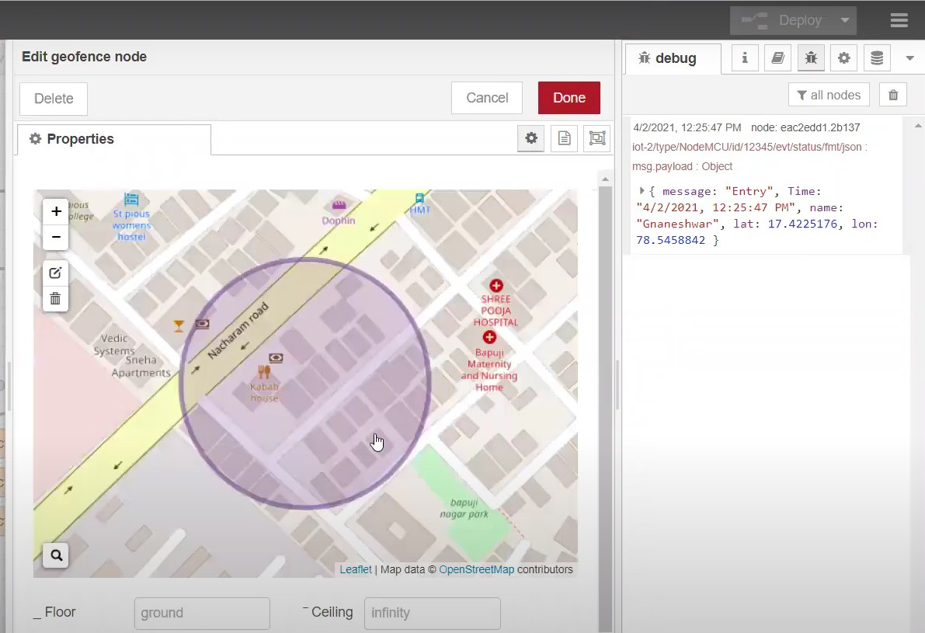Created the geofence node
* Python script sending requests to IBM Cloud

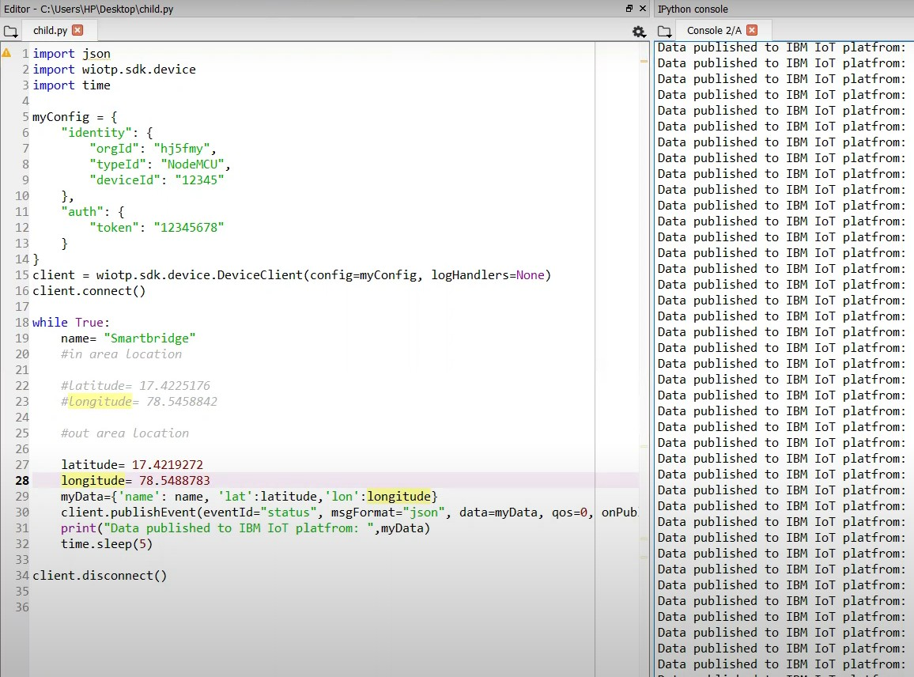

* 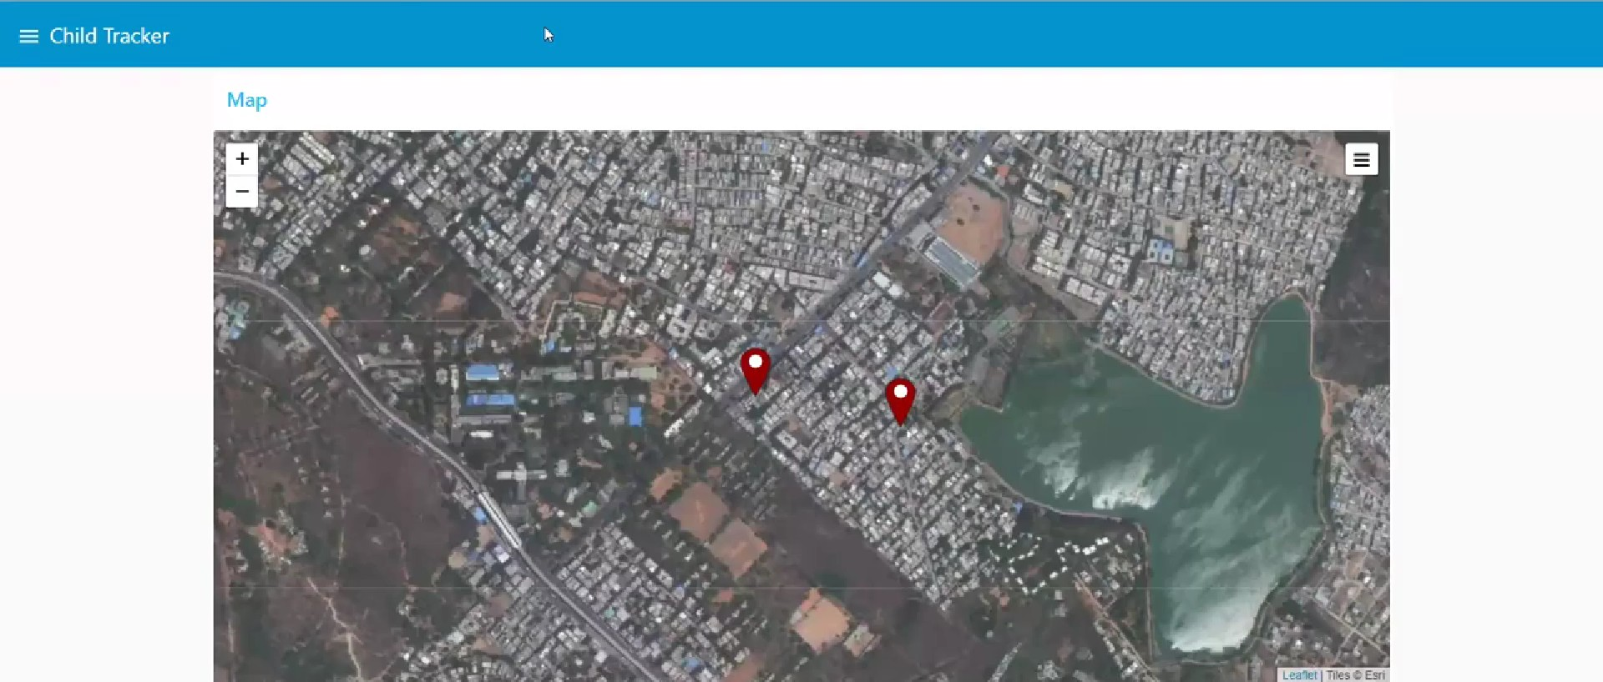After running the script, the web UI shows “Person is not in the particular area”

Result: Successfully developed a web application using Node-RED